THEMENBLOCK 14: Reading & Literature

TASK SET A1: THE ANNOTATOR VS. THE PURIST

PART 1 — Individual Long Turn
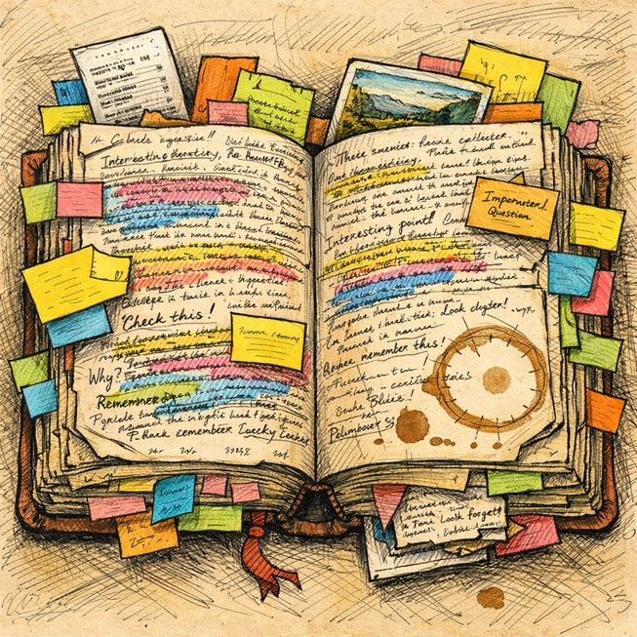

Task
Give a five-minute talk on how people physically interact with books in which you
- Describe, compare and contrast the two illustrations above.
- Analyze the different philosophies these approaches represent regarding book ownership and reading.
- Discuss which approach you prefer and explain whether books should be preserved or personalized.

PART 2 — Paired Activity

Task
Your English class is organizing a debate on the topic: 'Print books will always be superior to e-readers.' One of you will argue FOR print books, the other AGAINST. Before the debate, discuss these aspects and prepare your strongest arguments:
- The sensory experience of reading (touch, smell, page-turning)
- Practical considerations (portability, storage, cost)
- Environmental impact of both formats
- The role of annotations and highlighting in each format
- How each format affects reading comprehension and retention

TASK SET A2: THE READING AESTHETIC VS. ACTUAL READING

PART 1 — Individual Long Turn


Task
Give a five-minute talk on reading culture in the social media age in which you
- Describe, compare and contrast the pictures above.
- Analyze why people share aestheticized images of reading and what this reveals about modern culture.
- Discuss whether social media 'reading culture' helps or harms genuine reading habits.

PART 2 — Paired Activity

Task
Your school's book club wants to attract new members. You are planning the club's activities for the coming year. Discuss the following ideas and agree on THREE to implement:

- Monthly themed reading challenges with social media hashtags
- Cozy reading sessions with refreshments (no phones allowed)
- Author video calls or visits
- Book-to-film comparison evenings
- 'Blind date with a book' wrapped book exchanges

TASK SET A3: THE BOOK VS. THE ADAPTATION

PART 1 — Individual Long Turn


Task
Give a five-minute talk on books and their screen adaptations in which you
- Describe, compare and contrast the pictures above.
- Discuss the differences between experiencing a story through reading versus watching an adaptation.
- Evaluate whether adaptations enhance or diminish the original work, using specific examples if possible.

PART 2 — Paired Activity

Task
You are working with a consultant to create a new student literary magazine for your school. Discuss the following elements and agree on THREE priorities for the first issue:
- Student-written book reviews and recommendations
- Interviews with local or online authors
- Original creative writing section (stories, poems)
- A 'Book vs. Film' comparison column
- Reading challenges and interactive content for social media

TASK SET B1: THE TRANSFORMATIVE POWER OF READING

PART 1 — Individual Long Turn
Quote 1:
"A reader lives a thousand lives before he dies. The man who never reads lives only one."
— George R.R. Martin, Fantasy Author
Quote 2:
"Books are a uniquely portable magic."
— Stephen King, Horror Author

Task
Give a five-minute talk on the power of reading in which you
- Analyze and compare the two quotes above, discussing what each author means by their statement.
- Evaluate how reading fiction specifically can transform a person's perspective and understanding.
- Describe your own experience with a book that significantly affected you and explain why.

PART 2 — Paired Activity

Task
Your school wants to launch a 'Read More' campaign to encourage students to read for pleasure. You are helping to plan the campaign. Discuss the following approaches and agree on THREE to include:

- Celebrity/influencer book recommendations and videos
- A school-wide 'Drop Everything and Read' (DEAR) time weekly
- Student book ambassadors who promote reading peer-to-peer
- A reading reward system with prizes for books completed
- A comfortable new reading space in the school (reading corner/room)

TASK SET B2: THE FUTURE OF READING

PART 1 — Individual Long Turn
Quote 1:
"It doesn't matter how good or bad the product is, the fact is that people don't read anymore."
— Steve Jobs, Apple Co-founder (2008 Interview)
Quote 2:
"A book is a curious artifact—complex and efficient, compact, pleasant to handle, lasting centuries. It needs only light, a human eye, and a human mind."
— Ursula K. Le Guin, Science Fiction Author

Task
Give a five-minute talk on the future of reading in which you
- Critically discuss the two quotes above and state your opinion on each perspective.
- Analyze whether reading is truly declining or simply changing form in the digital age.
- Evaluate what might be lost and what might be gained as reading habits evolve.

PART 2 — Paired Activity

Task
You have been granted a fifteen-minute interview with a successful author visiting your school. Before the meeting, discuss which topics to focus on and agree on THREE main questions to ask:

- Their personal reading habits and favorite books growing up
- The impact of social media (like BookTok) on book sales and readership
- Advice for young people who want to become writers
- How they feel about adaptations of their work (or works they love)
- Their views on e-books vs. physical books

TASK SET C1: THE READING CRISIS AMONG YOUNG PEOPLE

PART 1 — Individual Long Turn

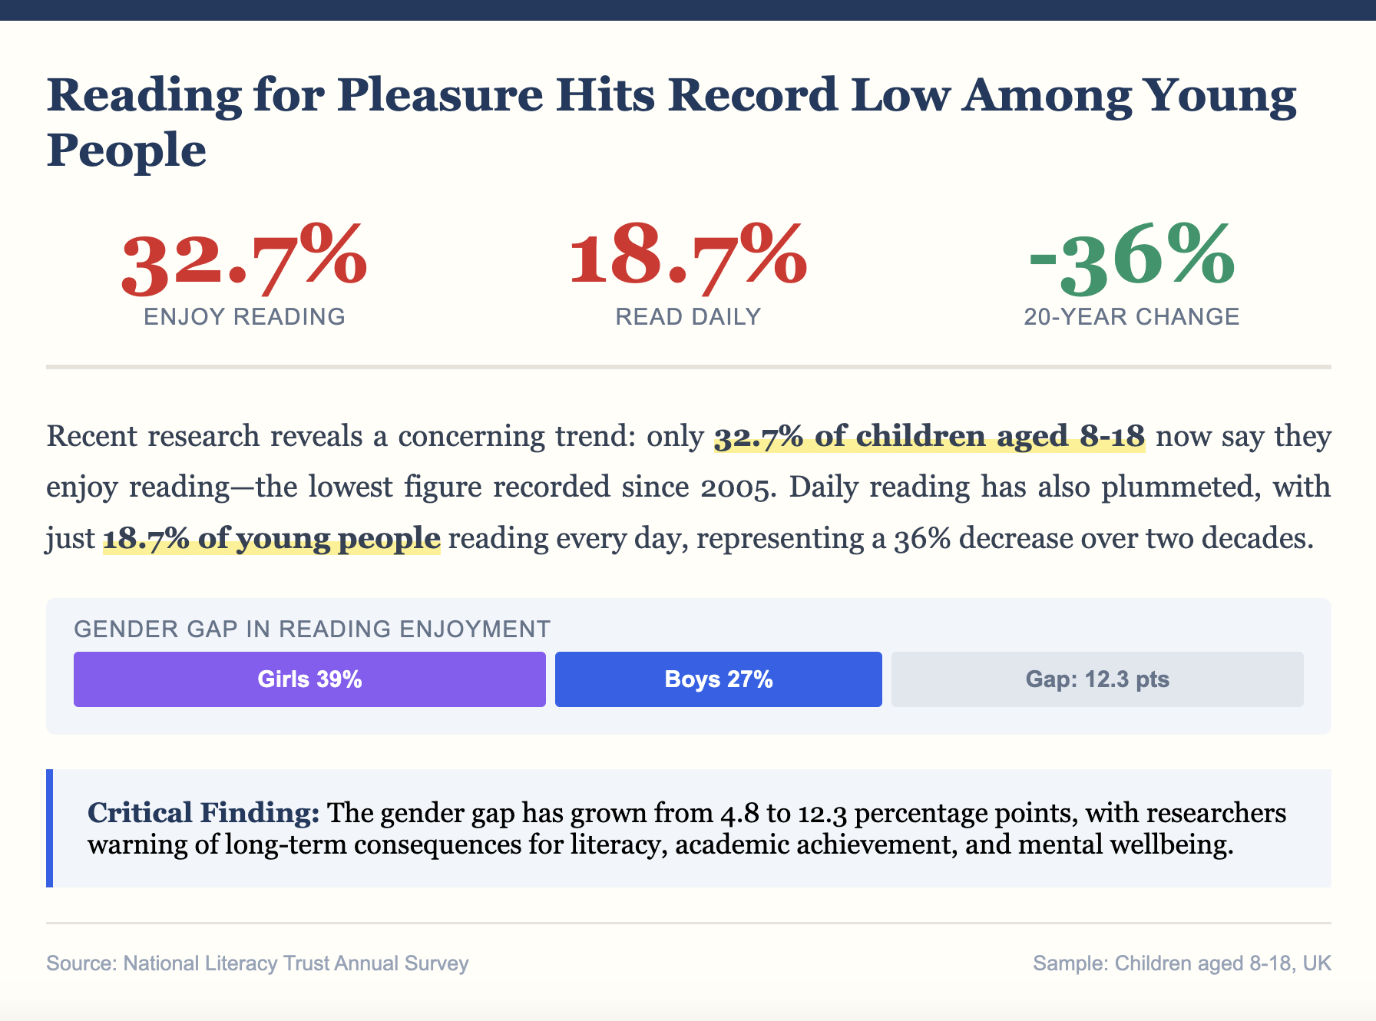

Task
Give a five-minute talk on declining reading habits among young people in which you
- Explain the key findings presented in the text extract above.
- Analyze the possible causes behind these trends (technology, education, lifestyle changes).
- Discuss what could be done to reverse these trends and whether this is important.

PART 2 — Paired Activity

Task
Your school is organizing a 'Digital Detox Reading Week' to encourage students to disconnect from screens and read physical books. Discuss and agree on the following aspects:
- How long the 'detox' should last (full week, specific hours, lunch breaks only)
- What activities to include (silent reading, read-alouds, book swaps)
- How to handle students who are resistant or struggle to participate
- Whether teachers should participate and lead by example
- How to measure success and gather feedback

TASK SET C2: THE BOOKTOK REVOLUTION

PART 1 — Individual Long Turn

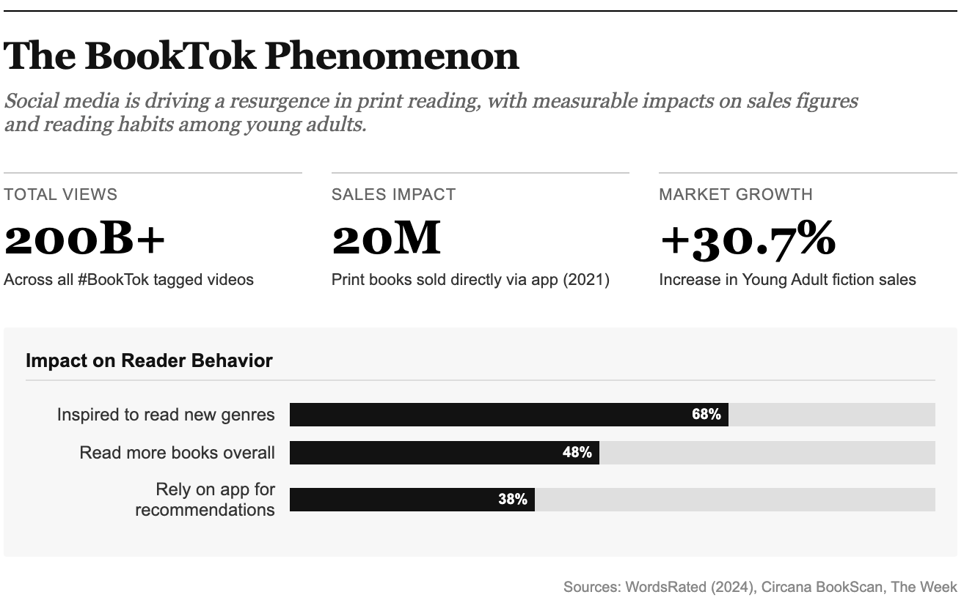Task
Give a five-minute talk on the BookTok phenomenon in which you
- Summarize the key statistics presented above and explain what they reveal.
- Analyze how social media has changed the way young people discover and discuss books.
- Commen on whether BookTok is positive or negative for reading culture.

PART 2 — Paired Activity

Task
Your class is conducting research on how social media affects reading habits among teenagers. Discuss the following research questions and agree on THREE to focus your study on:

- Does exposure to BookTok increase or decrease time spent reading?
- How does BookTok influence which genres and titles young people choose?
- Do BookTok recommendations lead to deeper engagement or just surface-level reading?
- What role do 'aesthetic' and 'emotional reaction' videos play in book choices?
- How does BookTok compare to traditional book recommendations (teachers, librarians, parents)?

